**5 DAYS BIG FIVE SAFARIS MURCHISION FALLS NATIONAL PARK AND ZIWA**

Our 5 days safari to the North Western Uganda takes us to the land of BIG FIVE that’s Rhinos at Ziwa Rhino Sanctuary and Lion, Elephants, Buffalos and Leopards at Murchison Falls National Park. We shall also enjoy a Nile cruise to Bottom of the falls which is so interesting.

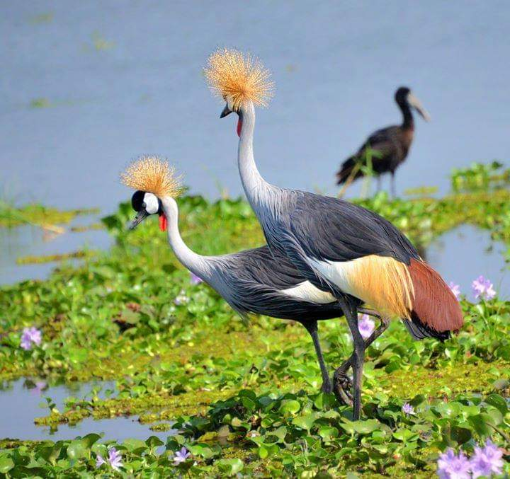

**DAY 1: ARRIVAL AT ENTEBBE INTERNATIONAL AIRPORT**

You will be welcomed by a representative of FRIENDS NATURE SAFARIS who will transfer you to your hotel in Kampala or Entebbe. Depending on the time of arrival, our guide will take you on a city tour for an exciting introduction in the capital. Visit some interesting and historical sites like Mosques, Uganda Museum and African Craft Village buying souvenirs. We also advise you to have money changed today. Dinner and overnight at

ACCACIA LODGE (Any Equivalent)

**DAY 2: KAMPALA –ZIWA RHINO SANCTUARY –MURCHISION FALLS NATIONAL PARK**

After breakfast we board on our safari van to the North western part of Uganda, we shall pass through known Luwero triangle to Nakasongola district then branch off, drive to Ziwa Rhino Sanctuary for tracking Rhinos after that we have late lunch (You note that this sanctuary is the only place in Uganda where you can see Rhinos in wild since they we poached to extinct), after that we shall continue to Chobe Safari Lodge or any Equivalent for dinner and overnight stay.

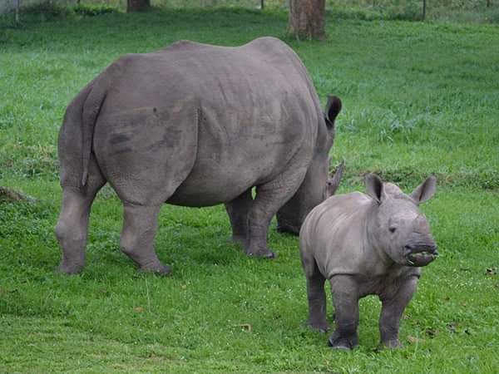

**DAY 3: GAME DRIVE AND BOAT CRUISE**

Early morning, we go with our packed breakfast for a game drive we shall pass in Tangi Gate to the northern bank to see animals it’s the highlight of our safari, we hope to see animals like Bufallos,Lions,leopard ,Girffes,Elepants and many more, we shall have a picnic breakfast then drive to Paraa Safari Lodge for lunch and in the afternoon, we do a Nile cruise also interesting to the bottom of the falls, we may see animals we missed to see on a game drive here on boat since they come to River banks to drink water ,Your guide will serve you snacks and drinks. At the bottom we shall leave the boat and hike to the Top of the falls to see the Mighty River being squeezed in a Seven Meter Gorge which forms rainbow and causes rain to drop at this place all the time, after that we shall find our driver and return to Chobe Safari Lodge for dinner and overnight stay.

**DAY 4:MURCHISON FALLS NATIONAL PARK TO QUEEN ELIZABETH NATIONAL PARK.**

After warm Breakfast we drive toward south western part of Uganda to Queen Elizabeth National Park which is the most visited in Uganda among others. It will take approximately 9-10 hours on road having a stopover at Lake Albert to view the Albertine Rift Valley from there we continue to Gate we enter the pay may see animals on our way to the lodge like Lions,Kobs and many more. We check in at the lodge, dinner and overnight stay.

Accommodation:

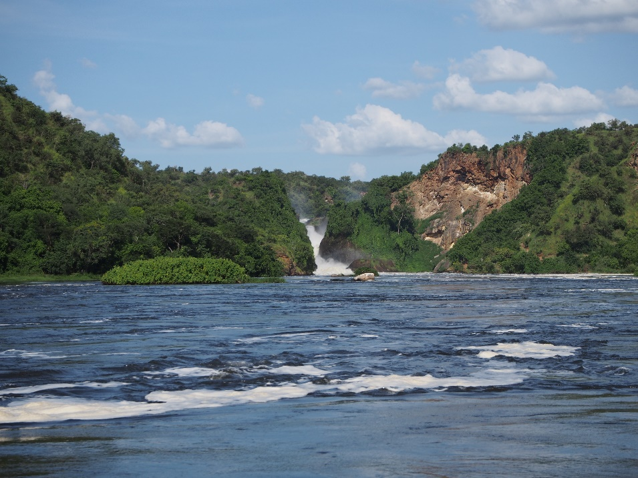

**DAY 5: QUEEN ELIZABETH NATIONAL PARK. (GAME DRIVE AND BOAT CRUISE**

At the park, early morning, wake up take a cup of tea and head for the thrilling game drive at 6:00am. Game to view Lion, Elephant, Leopard, Buffalo, Hyena and a variety of Antelope species. After lunch enjoy the unique 2-hour boat ride on the Kazinga Channel. You will have a chance to view Hippos on close range, have a boat cruise at kazinga chanel, watch other bird species and there after transfer back to the lodge for Dinner and overnight at

• Accommodation: Enganzi Lodge in Queen Elizabeth National park

**DAY 6: QUEEN ELIZABETH NATIONAL PARK T** **BWINDI IMPENETRABLE**

Afterwards we depart to BWINDI IMPENETRABLE NATIONAL PARK. We will pass the southern sector of the park, called Ishasha and known for the tree-climbing lions and here we expect to see some of the lions resting on the branches of trees. As we are getting out of this beautiful park to continue to Bwindi, Finally we arrive and check in at our Lodge.

**DAY 7: BWINDI IMPENETRABLE FOREST NATIONAL PARK**

In the morning we take our breakfast and assemble for briefing according to the group which we are going to trek/track about the does and donots.This activity is one of highlight of our safari, meeting with the gentle giants of Bwindi, Especially hikers will love the gorilla trekking in the beautiful ecosystem of the park. It is difficult to foresee how many hours you will hike, it may take two to eight hours. Expect to walk a long distance in steep and muddy conditions, sometimes with rain overhead, before you encounter any gorillas. But we found these creatures it is very rewarding and interesting as you observe them closely while they eat, play and rest. A unique and unforgettable experience! For conservation purposes, time spent with the gorillas is limited to one hour. The ranger guide always briefs you on how to behave with these giant apes. After the trek we return back to lodge for lunch and evening at leisure. Dinner and overnight at Silver Back Lodge Luxury (Any Equivalent).

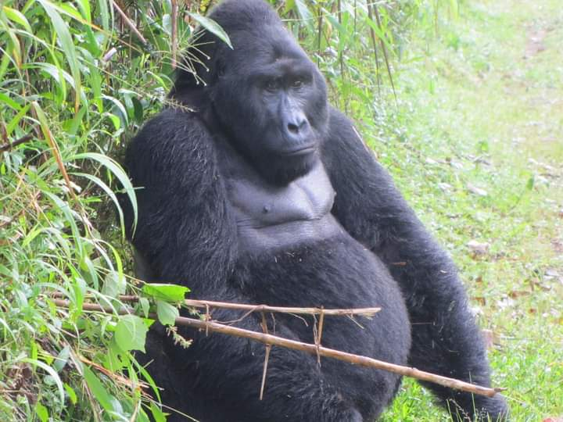

**DAY 8: TOP OF THE FALLS –KAMPALA**

In the morning after a relaxed breakfast you will travel back to Kampala. On the way back to the city you will have lunch on the way, stop at the craft shops to souvenirs and in evening we enjoy Kampala by Night Tour

Driving time: ± 10 hour

Acacia Lodge in Kampala

**DAY 9: KAMPALA TO AIRPORT**

Enriched with an experience of a lifetime and unforgettable memories you will say goodbye to the Pearl of Africa. Depending on the time of departure you will be transferred to the airport for your flight back home. We are looking forward to seeing you again.